Crikey what a day – single page
Designed by Carol Barron for the Scrapbook Club
KCRIKEY $29.95
Materials in this kit: Kaisercraft into the Wild Collection:
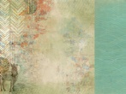 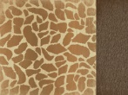 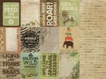
Savannah Giraffe Zoo
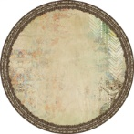 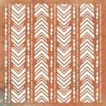 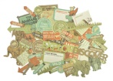
Outback diecut diecut Desert ½ sheet Collectables
WOW Crikey and Crocodile heading , Green Tara Burlap natural, string and burlap leaves, Brown Button . Photos and instructions.
You will need: two 3x4inch landscapape photos (or one 4x6inch photo) Kaisercraft inks Avacado, Green, Island, Lagoon and Vintage. Ranger glossy accents.
Preperation: Ink Crikey in Avacado then ink the edges in Green adding a little more hear and there not to much. Then ink the Crockadile firstly in Island then ink the edges in Lagoon adding a little more hear and there not to much. When this is nearly dry ink the edges in vintage. When totaly dry glossy accents.
Note: distress and ink in Lagoon each piece of paper as you go.
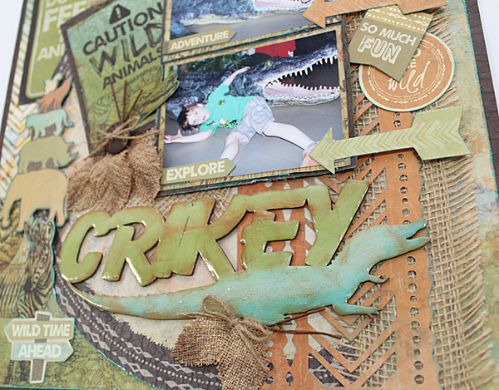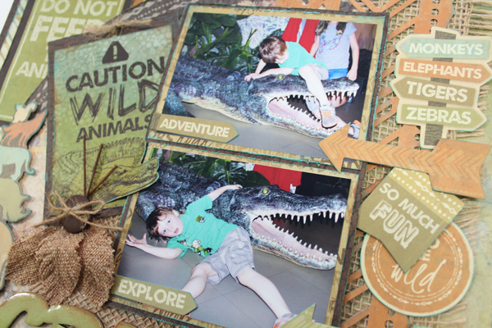
Instructions:
- Cut a 10x10 inch square from the centre of “Giraffe” we are using the outside boarder as the backing, brown side facing out. Put the 10inch square to one side.
- Next is “Savannah”, trim ½ inch from the top and ½ inch from the right side. This is so we can keep the lovely zebra in tacked. Using your craft knife fussy cut around the zebra’s head from the left side of its body down and around to the end of its neck on the right. Adhere evenly to the boarder of “Giraffe”.
- Trim 3inch of the diecut “Outback“ down the right side. Cutting off the kolala. Adhere to “Savannah” 1inch from the left.
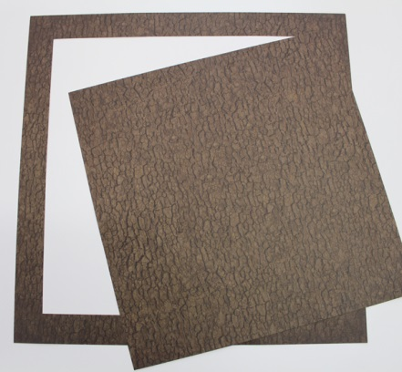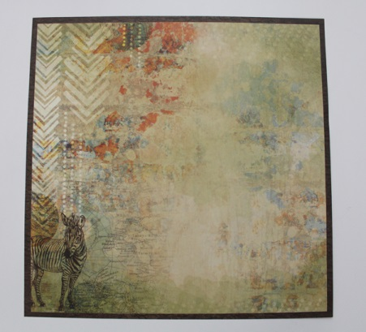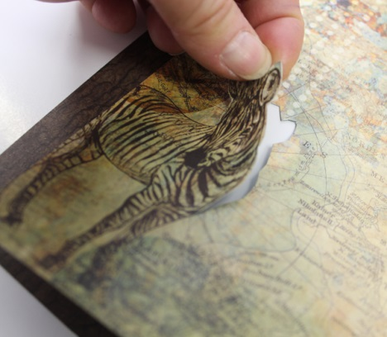
- Adhere your burlap ¾ inch from the right. Put the left over burlap to one side.
- Cut the diecut “Desert” 3inches from the left side (keeping that little extra piece of pattern in tacked). Trim ¼ inch off each end. ink in lagoon and adhere 1½ inches from the right.
- Next is “Zoo”cut verticall at 6inches. We are using two of the cards “Do Not Feed The Animals” and “Caution Wild Animals” cut both out .
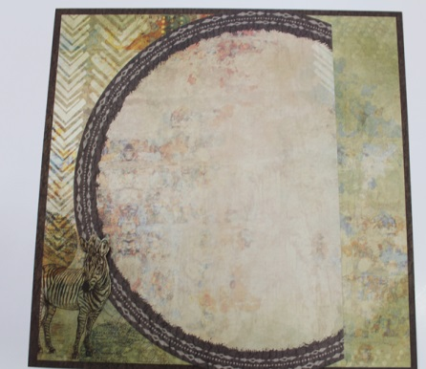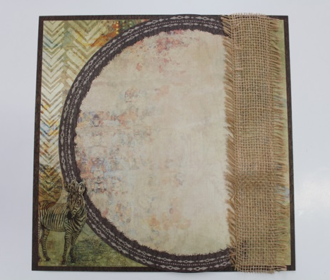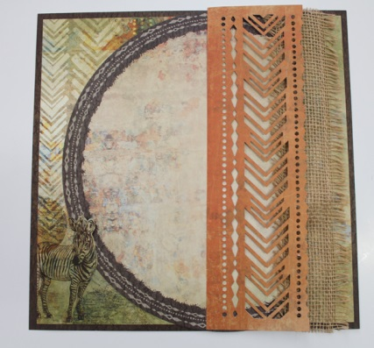
- Distress and ink “Do Not Feed the Animals” punch a small hole through the top and tie through some string. Adhere to the top left corner and just under the diecut “Outback”
- Cut a mat from the 10inch square from “Giraffe” 4½ x 6¾ inches. We are using the brown side.
- Cut two mats 4¼ x 3¼ inches from the left over piece of “Zoo” .We are using the cream printed side. Adhere your two landscape photos evenly to the centre. Now adhere your framed photos evenly to the large mat from “Giraffe”.
- Adhere the photos 1inch from the top and 2½ inches from the right side. Use foam tape. (Do not peel off the foam tape on the left), as we are sliding another card under.
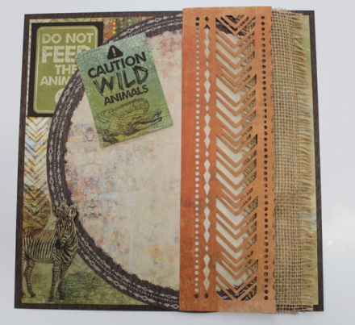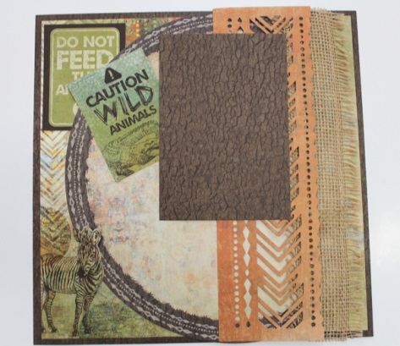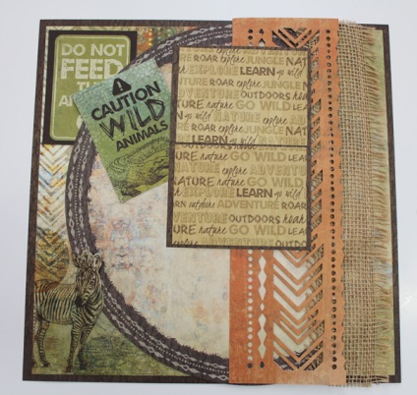
- Distress and ink the card “Caution Wild Animals” fussy cut around the crocodiles head and a little of the right side of its tail. Adhere to the small 3½ x4½ inch card, do not put any tape under the crocadiles head. Punch a hole through the top and tie a piece of string through the hole. Adhere on an angle 1½ inches from the left and 1½ inches from the top. Lift the Crocodiles head so its just over the side of the photo.
- Adhere the left over piece of burlap just under the bottom left of your photos.
- Sought the Collectables using the photo copied picture as a guide. Adhere using double sided tape and foam tape alternating between the two to give dimension.
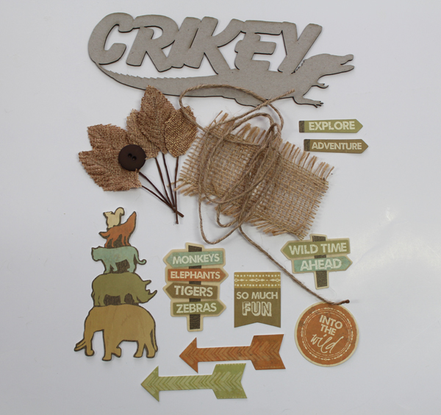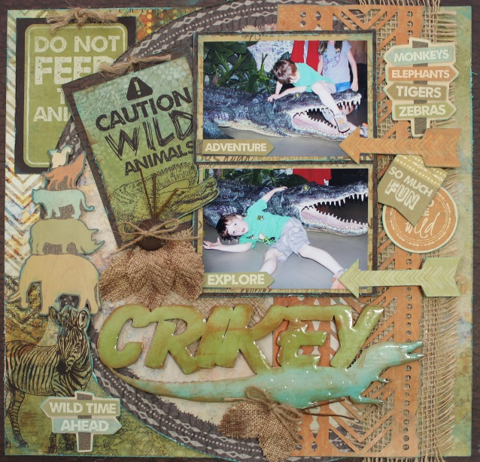

- Adhere the WOW Crikey and Crocodile Flourish the bottom of the layout.
- Tie a piece of string through the button and tie a bow.
- Adhere the leaves and button, tie a little string bow and adhere. Use the photo copied picture as a guide.

Enjoy, Carol

